**Name:Komal Singh**

**Roll No:60**

**Div:D15B**

**Advance Devops-7**

**Aim:** To understand Static Analysis SAST process and learn to integrate Jenkins SAST to SonarQube/GitLab.

**Theory:**

## **What is SAST?**

Static application security testing (SAST), or static analysis, is a testing methodology that

analyzes source code to find security vulnerabilities that make your organization’s applications susceptible to attack. SAST scans an application before the code is compiled. It’s also known as white box testing.

## **What problems does SAST solve?**

SAST takes place very early in the software development life cycle (SDLC) as it does not require a working application and can take place without code being executed. It helps developers identify vulnerabilities in the initial stages of development and quickly resolve issues without breaking builds or passing on vulnerabilities to the final release of the application.

SAST tools give developers real-time feedback as they code, helping them fix issues before they pass the code to the next phase of the SDLC. This prevents security-related issues from being

considered an afterthought. SAST tools also provide graphical representations of the issues found, from source to sink. These help you navigate the code easier. Some tools point out the exact location of vulnerabilities and highlight the risky code. Tools can also provide in-depth

guidance on how to fix issues and the best place in the code to fix them, without requiring deep security domain expertise.

It’s important to note that SAST tools must be run on the application on a regular basis, such as during daily/monthly builds, every time code is checked in, or during a code release.

### **Why is SAST important?**

Developers dramatically outnumber security staff. It can be challenging for an organization to find the resources to perform code reviews on even a fraction of its applications. A key strength of SAST tools is the ability to analyze 100% of the codebase. Additionally, they are much faster than manual secure code reviews performed by humans. These tools can scan millions of lines of code in a matter of minutes. SAST tools automatically identify critical vulnerabilities—such as buffer overflows, SQL injection, cross-site scripting, and others—with high confidence. Thus, integrating static analysis into the SDLC can yield dramatic results in the overall quality of the

code developed.

**What are the key steps to run SAST effectively?**

There are six simple steps needed to perform SAST efficiently in organizations that have a very large number of applications built with different languages, frameworks, and platforms.

1. **Finalize the tool.** Select a static analysis tool that can perform code reviews of

applications written in the programming languages you use. The tool should also be able to comprehend the underlying framework used by your software.

1. **Create the scanning infrastructure, and deploy the tool.** This step involves handling the licensing requirements, setting up access control and authorization, and procuring the resources required (e.g., servers and databases) to deploy the tool.
2. **Customize the tool.** Fine-tune the tool to suit the needs of the organization. For example, you might configure it to reduce false positives or find additional security vulnerabilities by writing new rules or updating existing ones. Integrate the tool into the build

environment, create dashboards for tracking scan results, and build custom reports.

1. **Prioritize and onboard applications.** Once the tool is ready, onboard your applications. If you have a large number of applications, prioritize the high-risk applications to scan first. Eventually, all your applications should be onboarded and scanned regularly, with

application scans synced with release cycles, daily or monthly builds, or code check-ins.

1. **Analyze scan results.** This step involves triaging the results of the scan to remove false positives. Once the set of issues is finalized, they should be tracked and provided to the deployment teams for proper and timely remediation.
2. **Provide governance and training.** Proper governance ensures that your development teams are employing the scanning tools properly. The software security touchpoints

should be present within the SDLC. SAST should be incorporated as part of your application development and deployment process.

# **Integrating Jenkins with SonarQube:**

| Windows installation  Step 1 Install JDK 1.8  Step 2 download and install jenkins  <https://www.blazemeter.com/blog/how-to-install-jenkins-on-windows>  **Ubuntu installation**  [**https://www.digitalocean.com/community/tutorials/how-to-install-java-with-apt-on-ubuntu-20-04#installing-the-default-jre-jdk**](https://www.digitalocean.com/community/tutorials/how-to-install-java-with-apt-on-ubuntu-20-04#installing-the-default-jre-jdk)  Step 1 Install JDK 1.8  sudo apt-get install openjdk-8-jre  sudo apt install default-jre  <https://www.digitalocean.com/community/tutorials/how-to-install-jenkins-on-ubuntu-20-04>  [Open SSH](https://www.cyberciti.biz/faq/ubuntu-linux-install-openssh-server/) |
| --- |

## **Prerequisites:**

* [Jenkins installed](https://www.digitalocean.com/community/tutorials/how-to-install-jenkins-on-ubuntu-20-04)
* [Docker Installed](https://docs.docker.com/engine/install/ubuntu/) (for SonarQube)

(sudo apt-get install docker-ce=5:20.10.15~3-0~ubuntu-jammy docker-ce-cli=5:20.10.15~3-0~ubuntu-jammy containerd.io docker-compose-plugin)

* SonarQube Docker Image

**Steps to integrate Jenkins with SonarQube**

1. Open up Jenkins Dashboard on localhost, port 8080 or whichever port it is at for you.
2. Run SonarQube in a Docker container using this command -

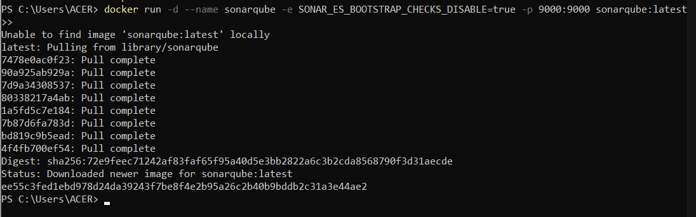

Warning: run below command only once

docker run -d --name sonarqube -e SONAR_ES_BOOTSTRAP_CHECKS_DISABLE=true -p 9000:9000 sonarqube:latest

1. Once the container is up and running, you can check the status of SonarQube at localhost port 9000.

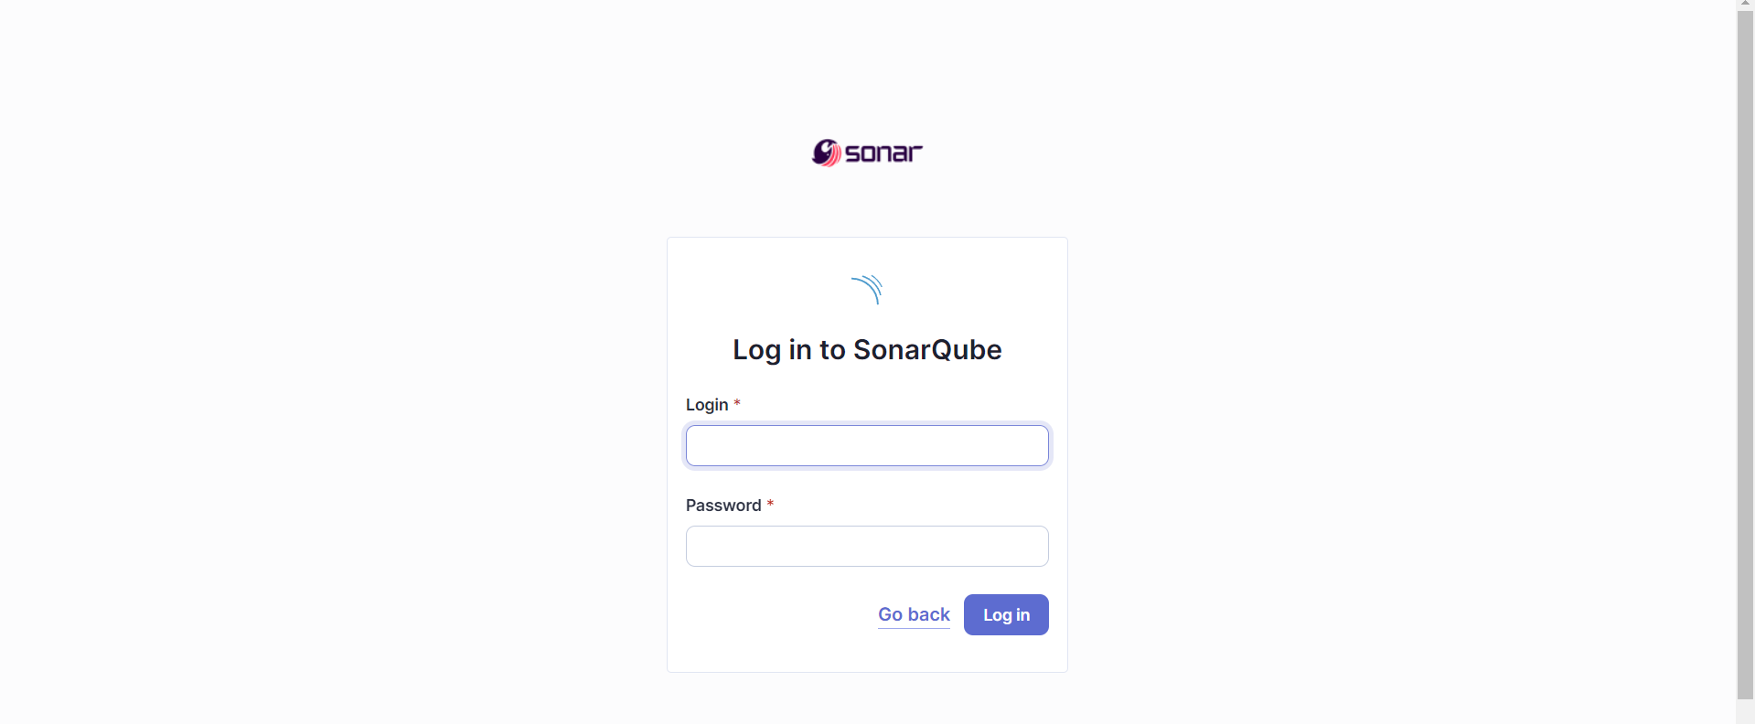

1. Login to SonarQube using username *admin* and password *admin*.
2. Create a manual project in SonarQube with the name **sonarqube**
3. 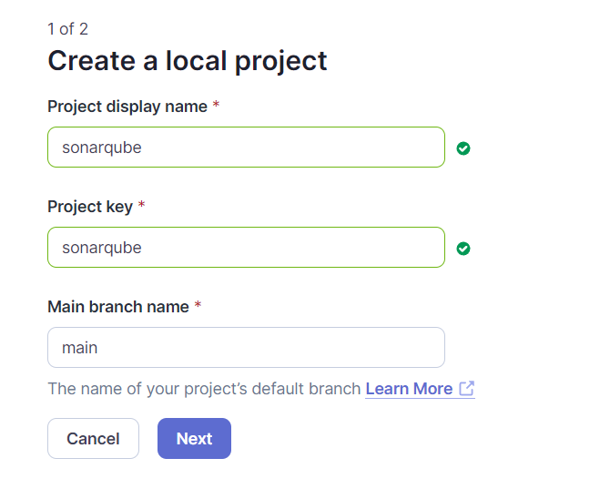

Setup the project and come back to Jenkins Dashboard.

Go to Manage Jenkins and search for SonarQube Scanner for Jenkins and install it.

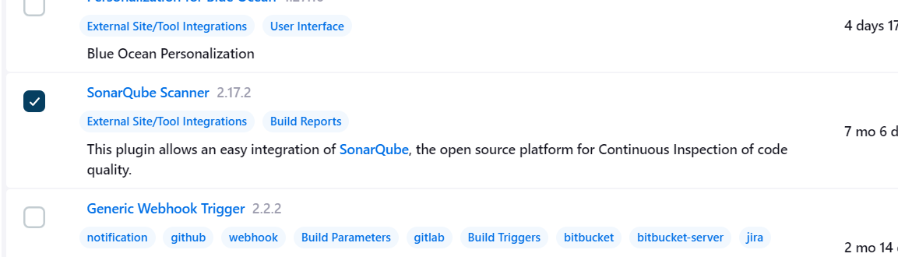

1. Under Jenkins ‘Configure System’, look for SonarQube Servers and enter the details.

Enter the Server Authentication token if needed.

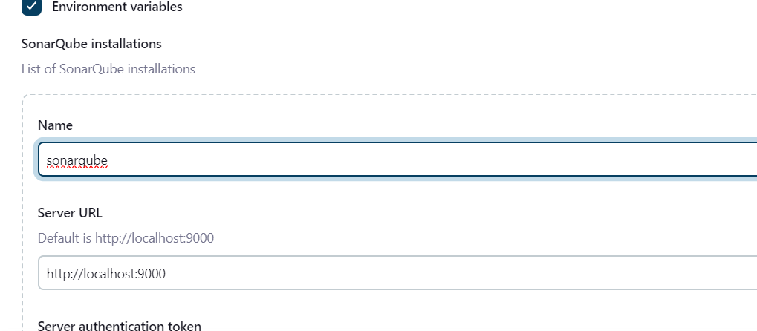

1. Search for SonarQube Scanner under Global Tool Configuration. Choose the latest configuration and choose Install automatically.
2. After the configuration, create a New Item in Jenkins, choose a freestyle project.

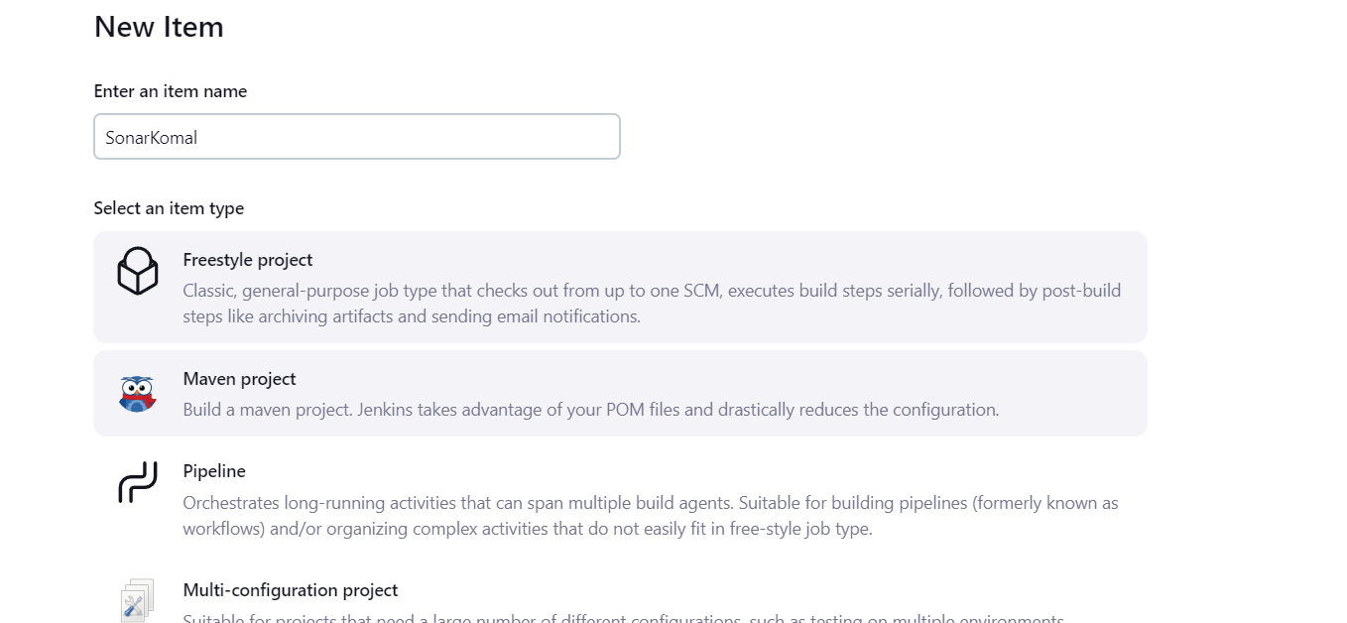

1. Choose this GitHub repository in Source Code Management. <https://github.com/shazforiot/MSBuild_firstproject.git>

It is a sample hello-world project with no vulnerabilities and issues, just to test the integration.

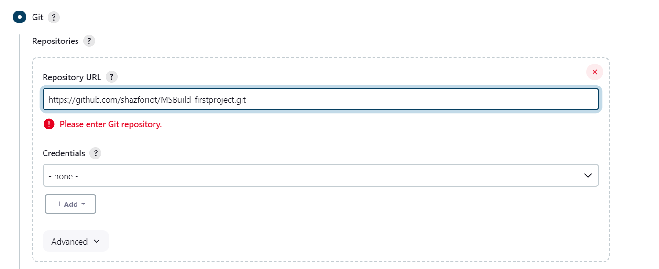

1. Under Build-> Execute SonarQube Scanner, enter these Analysis properties. Mention the SonarQube Project Key, Login, Password, Source path and Host URL.
2. Go to http://localhost:9000/<user_name>/permissions and allow Execute Permissions to the Admin user.
3. 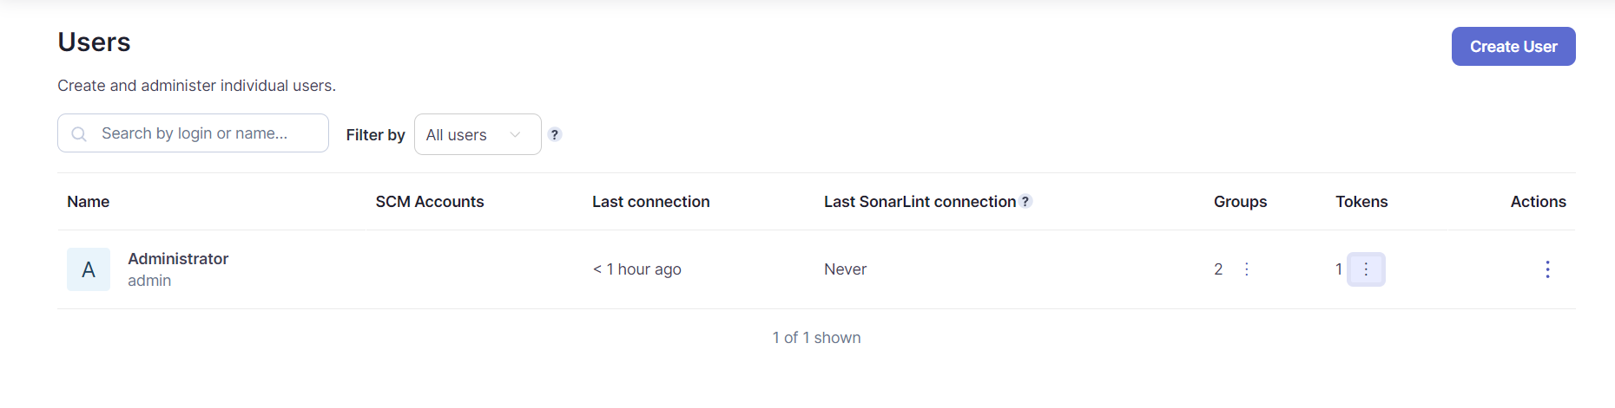
4. Run The Build.
5. 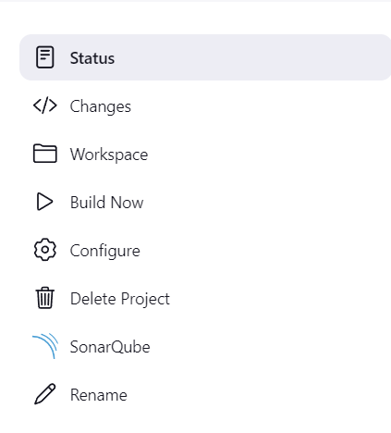

Check the console output.

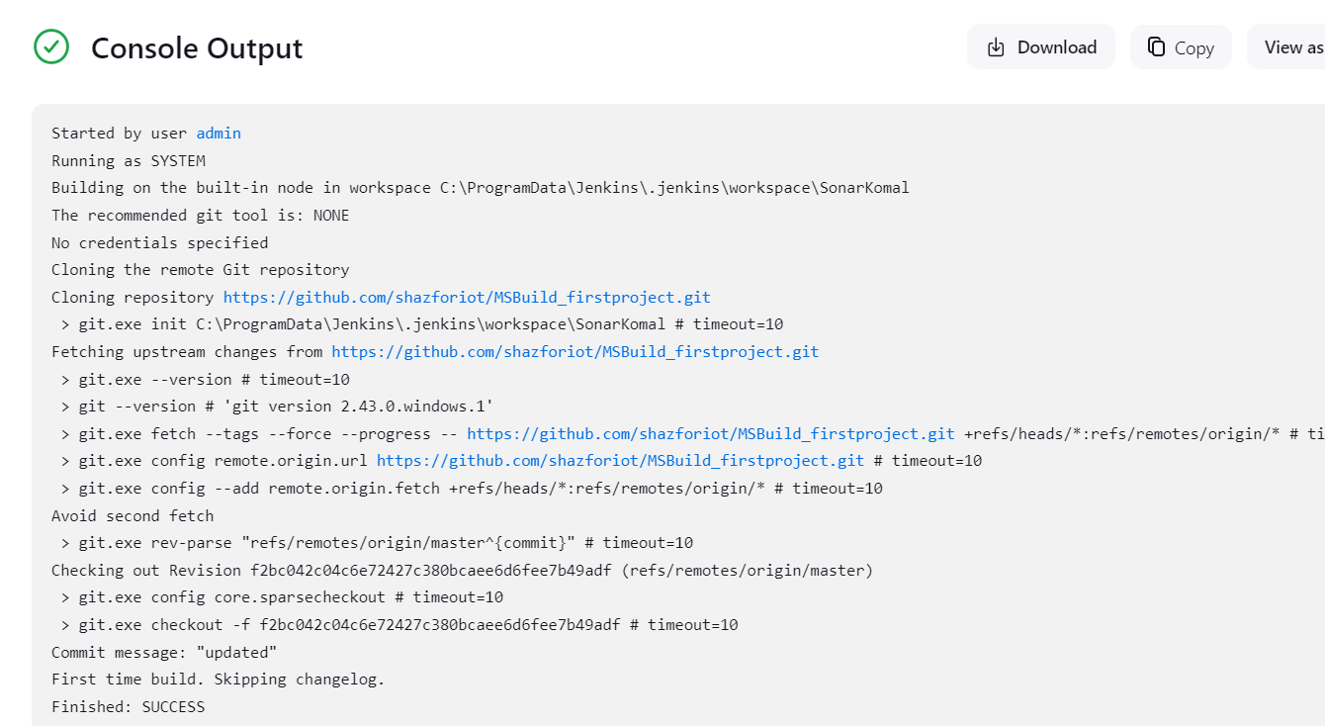

1. Once the build is complete, check the project in SonarQube.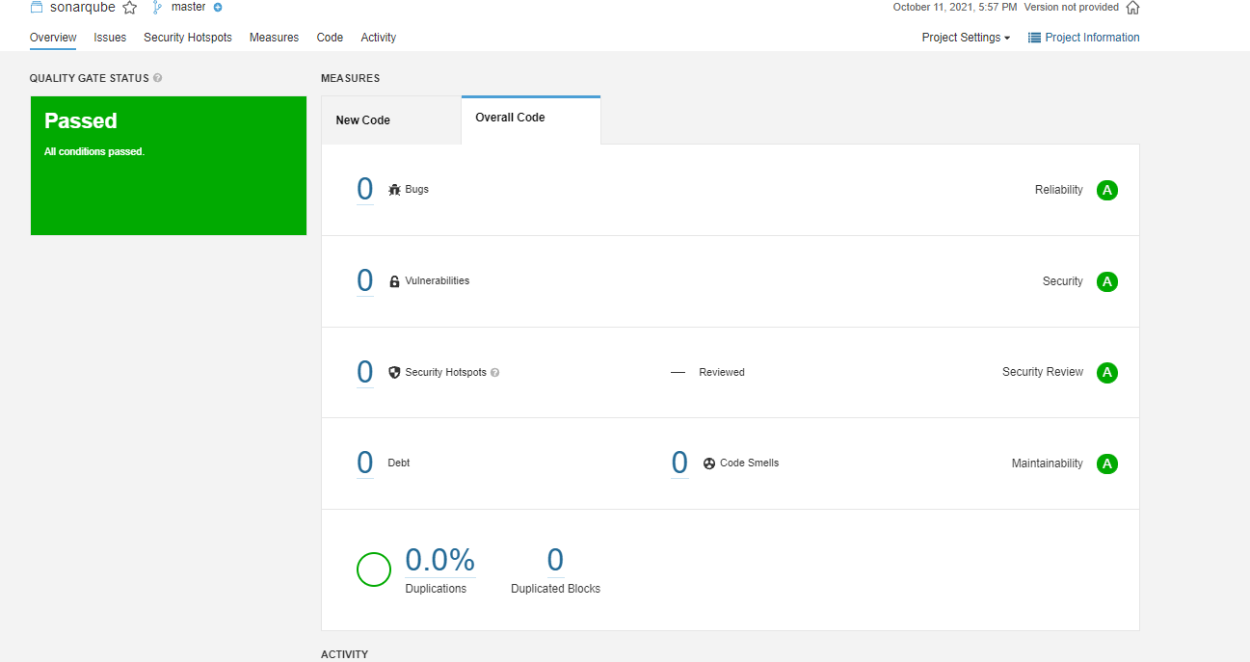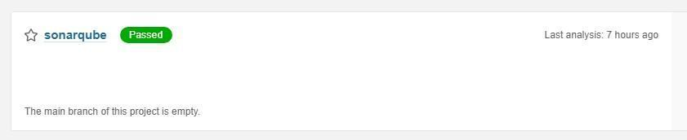

In this way, we have integrated Jenkins with SonarQube for SAST.

### **Conclusion**

In this experiment, we have understood the importance of SAST and have successfully integrated Jenkins with SonarQube for Static Analysis and Code Testing.